Project ‘Innovational software from Graphics and CAD area’ and global market.

As per a report by Transparency Market Research, the global computer graphics market is likely to rise at a steady 5.5% CAGR between 2016 and 2024 to become worth US$211.60 bn by 2024 from US$130.91 bn in 2015.
The computer graphics market has been segmented on the basis of component and application. Based on component, the market has been further classified into hardware component and application software component. By application, the market is further classified into CAD, image processing, entertainment (3D/animation/visual effects (VFX), user interface and others (education graphics, etc.). Our project is focused basically on application segment though some of our methods can be used in application software component too. Computer graphics application software market volume is about $18 billion
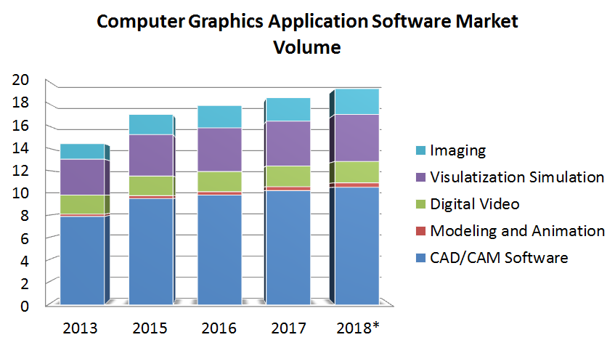

App Images Generator relates to segments CAD/CAM software, modeling and Animation, Visualization Simulation and Imaging. This program gets in a category the Graphic Editors, but as against popular graphic editors has wider scope. Images Generator can be used for creation of beautiful images, for editing of photo, for fitting of clothes, for creation of illustrations and advertisements, for design of a printed matter, for creation of WEB graphics, for creation of electrical circuits and technical drawings and for many other purposes. We expect distribution of the program up to several tens millions copies.

Our technologies can be used for creation of such programs, as the program of the analysis of images and selection of a part of the image, the program of creation of portraits from a photo, the program for creation of gif animations.

We plan to apply our algorithm of automatic designing of connections of printed-circuit-boards in systems of PCB design. World printed circuit board (PCB) production reached an estimated $58.2 billion in 2017. it has been estimated that, the global PCB printed circuit board design software would show the CARG growth rate of 12.9% with $4,755 million by the year 2026.

On the basis of our methods we execute plug-in for Photoshop and AutoCAD.

We assume that the profit of our project will make some millions per one year

