Innovation application Images Generator.
By Sergey Leontyevich Panasyuk, Panasoft
24/11/2016
Ukraine
Phone +79787642060
Email: imgenpanasoft@gmail.com
Firm Panasoft has developed a graphical application Images Generator that combines properties of the modern graphic editor with properties of computer-aided design program. Images Generator has a number of features not found in other programs. This include the following.

- The program make possible creation of beautiful images that can be used in the textile or paper industry or in other areas. Examples are shown in the figures below (pic.1, pic.2).
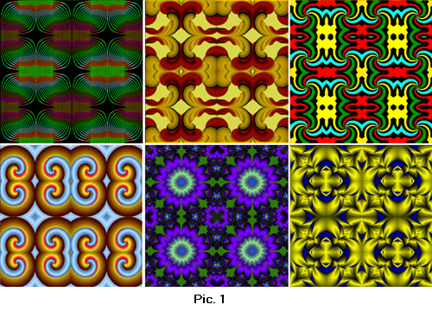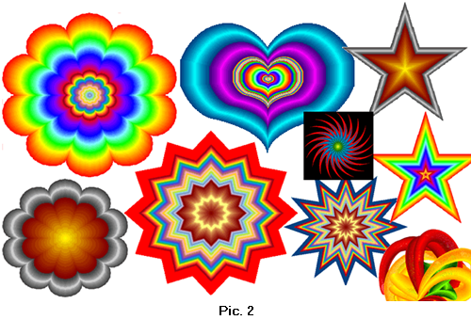
- The program allows you creation of images with use of multi-colour lines of variable width and volumetric lines (pic.3, pic.4).
- 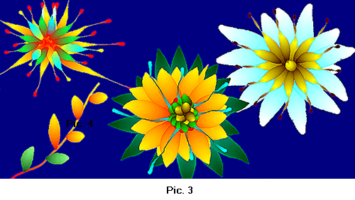
.
- Large number of built-in curves is included in Images Generator. These curves are divided into two classes that are Shapes and Mathematical Curves. Curves of type Shape are the closed non-intersecting lines.
The built-in curves can be used for obtaining of unlimited number of derivative curves. The built-in and derivative curves are used for selection of a part of the image, for use as the trajectories and for other purposes. Compatibility with system AutoCAD is provided by using of dxf files (pic.5).
- 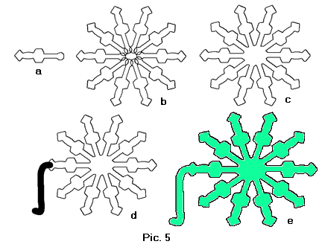
- The program allows creation of three-dimensional images that can be used for engineering and mathematical modelling (pic.6).
- 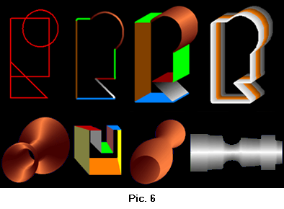
- Selection of image area based upon the colors in the image is used. Images Generator provides two modes: “In Range of Colors” and “From Background”. The first mode allows to selecting area of similar colors. The second mode allows selecting image area from a background. Border of a background is the line which points color is in the given range (pic.7).
- 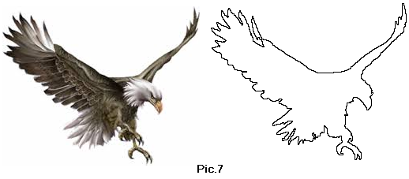
- Method of transformation of raster images provides various capabilities as creation images of faces from photos (pic.8, pic.9).
- 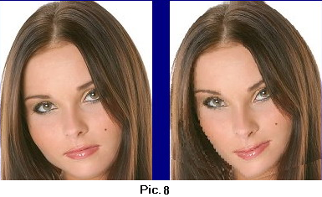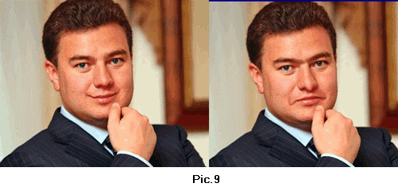
- Tooling of the Images Generator includes the convenient and effective tools for removal of unwanted blemishes, spots, scratches, creases or stains from a photo. Images Generator can be used to eliminate the sharp color transitions (pic.10).
- 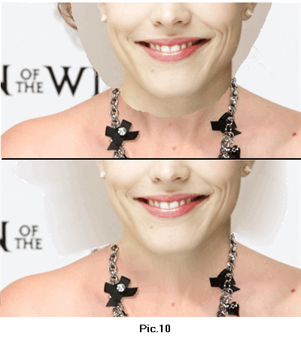
- The program provides storage of images of objects such as electrical symbols, hieroglyphs, pictures of animals and pieces of clothing. Used convenient way of a combination of these images provides simplicity of creation of different pictures – diagrams, landscapes, ads, identikits, texts, congratulatory cards and others. Images Generator may be used for fitting of clothes (pic.11).
- 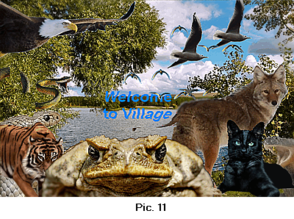
Having ample capabilities Images Generator is characterized by the small sizes and convenience of using. Such properties are provided by a number of innovative solutions. These solutions include tools Raster and Vector Brush, multi-color lines of variable width, use of various color models for selection of image parts, method of removal of image defects, raster images transformation method and others.

The scope of the program is processing photos and other images, development of Web graphics, creation of illustrations, advertisements, labels, development of various schemes and identikits, fitting of clothes and hairstyles and many more.
Images Generator pretend to be the workhorse for ordinary users and is useful addition to the toolkit of professional artists and designers. The program is mean for developing of creative abilities and can be used as developing toy for children.
Images Generator is available now and may be downloaded
Web site: http://www.imagesgenerator.com
Download: http://www.imagesgenerator.com/ImagesGeneratorSetup.zip
There are paid and free versions.

