Shape templates and multicolor lines.

By Sergey Leontyevich Panasyuk, Panasoft.
Marinesko str. 19A, r.12, Sevastopol, 99021, Ukraine

E-mail: p739@stel.sebastopol.ua
12.05.2009

Abstract

Methods of creation of images with use of shape templates and multi-color lines are considered. These methods can be used in programs of computer graphics as graphic editors. The user of the program can create unlimited amount of shape templates. The custom and built - in shape templates can be prescribed by the not crossed closed curve, consisting of pieces of a direct line. For curve parts color or a color sequence can be given. The image is created by repeated drawing multi-color lines at moving the mouse or in points of a trajectory. At use of trajectories multi-color lines may to be carried out under different angles and also may to be scaled in a horizontal and vertical direction. It let you to achieve a number of graphic effects as volumetric effect.
For parts of a curve not only color characteristics can be given, but also width and a level of a transparency. The part of a curve can be cut out and the open-ended line of a complex configuration can be used irrespective of an initial curve. Parts of a curve can be approximated by parametrical curves that will expand abilities of scaling of shape templates.

Keywords.

Shapes, shape templates, multicolor lines, creating images, 3D graphic, volumetric images, Vector brush, Raster brush, graphic editors, graphic tools

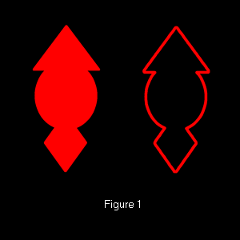
The shape templates here are understood as the following. We admit the shape of a figure is a rhombus. Position, sizes, proportions and angles of turn of figure may be changed and even so shape of figure will be a rhombus. The rhombus is one of special cases of shape templates, having the special name. Other special cases are the circle, a triangle, a parallelogram and others. In graphic editors shape templates allow to select part of the image. You can to apply for the selected image area fill or outline tools, graphic filters or converters.
Programs of computer graphics may to have a plenty of built - in shape templates. Built - in shape templates are realized on the base of well-known mathematical dependences. However if a program even have a plenty of the built - in shape templates it is impossible to meet all arising in practice requirements. Besides search of necessary shape templates at there plenty can to be a complicated problem. Using of the created by the own program user shape templates along with built - in shape templates is more preferable. Custom shape templates may essentially expand potential of the program.

The shape templates can be prescribed by the closed not crossed curve consisting of pieces of a direct line. Change of the sizes or angles of turn is achieved by change of coordinates of the ends of the pieces making a curve. To obtain such curve it is possible by the following way. With the help of the built - in shape templates and other tools of computer graphic the figure of the required shape is created. Imposing a rhombus, a circle and a triangle creates picture shown left of the figure 1. For obtaining of a shape template it is enough to obtain a boundary curve of the given picture.
For this purpose the methods, intended for selection of a part of the image [1-6], can be used. Such methods are used in graphic editor’s tools. These tools share on two groups. Tools, in which the border of selection is set in a manual mode by moving the mouse, relate to the first group. Tools, in which color characteristics of the image are used, relate to the second group. Tools belonging to the second group frequently are called as Magic Wand. Using tool Magic Wand of graphic editor Images Generator (http://www.imagesgenerator.com) let you to determine the external border of the one-coherent image area. Parameters of points of this area are in a given range. Parameter of a point is the value determined by color of a point. In different modes as parameters the following values are used: one component of RGB or HSL model of point color, any combination of this components or the sum of components of RGB model of point color. The range of allowable size of parameters is determined relative to parameter of the selected with mouse help base point.

One more program tool allows selecting the image area relative to background. Border of selected area consists of the points belonging to a given range of the given base parameter. As parameters the same values are used.

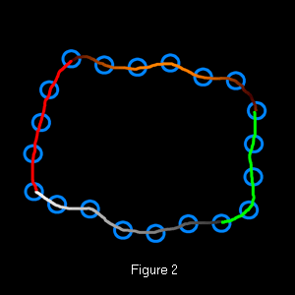
Result of application of these tools to the left picture of the figure 1 is the curve shown in the right picture of the figure 1. The length of pieces of which the curve consists can be chosen enough small and identical to all pieces except for pieces adjacent with points of a break of a curve. Length of pieces adjacent with points of a break can little differ. The concept of distance on a curve can be introduced. Distance between two points on a curve is the amount of pieces between these points. As coordinates of the ends of pieces are known, along a curve on identical distance with the given density markers of indication of the ends of pieces can be displayed. The selection of a point of a curve may be carried out by click on the appropriate marker. To select a part of a curve it is enough to set two points being final points. In such way the curve can be broken on some amount of parts.

Splitting of a curve into parts can be used to the different purposes. For a selected part of a curve color can be given. Pieces making this part will be carried out by this color. One more use is next. Colors of the ends of the selected part of a curve and the law of change of colors in an interval between these final points can be given. Such laws can be, for example, linear or sine wave change of color components. Pieces making selected part will be carried out by colors from obtained sequence of colors. The example of splitting of a curve and realization of the making a curve pieces by different colors is given in figure 2. Circles show markers. In program Images Generator the color sequence, which amount of colors equal to amount of the making a curve pieces, is formed. Each piece will be carried out by the appropriate color from this sequence.
Analogously, for making a curve pieces not only color, but also other parameters - width and a level of a transparency can be prescribed.

Parts of a curve can be approximated by splines and parametrical curves, for example, by Bezier curves. In this case the prescription of a curve will include the segments, which prescribe splines and parametrical curves. It will expand abilities of scaling of shapes.
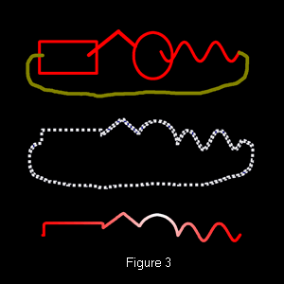
The part of the closed curve can be cut out and can be used irrespective of an initial curve. It enables obtaining of the description of having a complex configuration open-ended line. In figure 3 stages of obtaining of the description of having a complex configuration open-ended line are shown. At the first stage the figure, which segment of border has a required configuration, is created. At the second stage the border of this figure is determined. At the third stage the part of border is cut out, that is description of the pieces making this part are copied and saved in memory. These descriptions are used for realization open-ended lines of a complex configuration. For clearness the cut out part is drawn by different colors.

In program Images Generator the descriptions of the closed and open-ended multi-color lines are saved in memory and are used for creation of images. At pressing the button of the mouse or at mouse moving saved multi-color lines are drawn. The width of lines and frequency of drawing determine a kind of the created image. This tool is called as the Vector brush. Contrary if at moving of the mouse there is a copying of the raster image that the appropriate tool is named as a Raster brush.

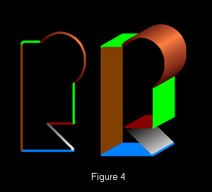
In program Images Generator for the prescribing of points, in which repainting of images of a Vector or Raster brush is carried out, trajectories can be used. Trajectories are created with the help of the same tools, which are used for selection of a part of images and for creation of shape templates. Trajectories allow providing uniform repainting of images with adjustable density.

One of using of a vector brush is creation of volumetric images. In figure 4 the vector brush and the image created at its consecutive realization are shown. Trajectory, which in this case is a piece of a direct line, is used for creation of this volumetric image. Angle of turn of a vector image in this example is constant. Generally angles of turn of the vector image in points of a trajectory can be different. If, for example, a trajectory is the circle and an angle of turn of the vector image varies from zero up to 360 degrees the image shown in figure 5 is created. In this case rotation of the vector image is carried out about a point. It is possible rotation of the vector image not only about a point, but also about vertical, horizontal or inclined axes.

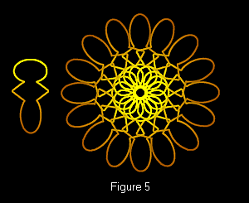

Advantage of vector images is that they can be scaled over a wide range. At movement of a vector brush on a trajectory its sizes can change in a vertical and horizontal direction. Scale factors of change of the sizes can be given as complex functional dependence. In each point of a trajectory with the help of these functional dependences scale factors on axis X and on an axis Y are set. Examples of moving of a vector brush on a trajectory with change of its sizes in a vertical and horizontal direction are shown in figure 6.

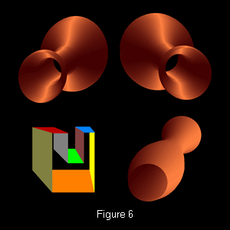

The image can be created by movement of a vector brush on a complex trajectory with simultaneous change of its width and height, an angle of turn about of the central point and angle of turn about vertical and horizontal axes. The example of such image is shown in figure 7.

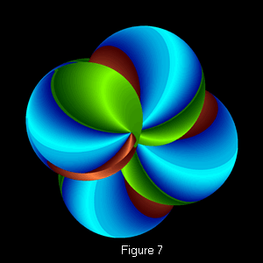

Opportunities of experimentation for creating images by this way are unlimited.

References

- Kaas M., Witkin A., Terzopoulos D. Snakes: Active Contour Models. // Int. Journal of Computer Vision. - 1987, N1, -p.312-331.
- Canny J.F. Finding edges and lines in images. / Master's thesis, MIT, Cambridge, USA, 1983
- R. Deriche, Fast Algorithms for Low-Level Vision, IEEE Transactions on Pattern Analysis and Machine Intelligence, v.12 n.1, p.78-87, January 1990
- Jan J. Koenderink , Andrea J. van Doorn, Generic Neighborhood Operators, IEEE Transactions on Pattern Analysis and Machine Intelligence, v.14 n.6, p.597-605, June 1992
- Sebastien Mavromatis , Jean-Marc Boï , Rémy Bulot , Jean Sequeira, Texture analysis using directional local extrema, Machine Graphics & Vision International Journal, v.13 n.3, p.289-302, January 2004
- Laurent Joyeux , Samia Boukir , Bernard Besserer, Tracking and MAP Reconstruction of line scratches in degraded motion pictures, Machine Vision and Applications, v.13 n.3, p.119-128, July 2002

Figure captions.

Figure 1. Boundary curve as shape template.

Figure 2. Multicolor line.

Figure 3. Obtaining of open-ended lines of a complex configuration.

Figure 4. Moving of Vector brush on trajectory

Figure 5. Moving and rotation of Vector brush

Figure 6. Moving of a Vector brush on a trajectory with change of its sizes in a vertical and horizontal direction

Figure 7. Simultaneous change of sizes and angles of turn at Vector brush moving

Author biography.
Scientist, and programmer with 30 years of experience in software and hardware systems design and development. Employers have included secret military organizations of the former Soviet Union. The founder and the head of software firm Panasoft. Led teams in development of patentable innovations in diverse areas, including image processing, PCB and IC CAD, automated systems of control and tests of electronic digital devices, measurement of electric values. The author about 40 scientific works and inventions.

