Innovational graphic editor Images Generator.

By Sergey Leontyevich Panasyuk, Panasoft.
E-mail: p739@stel.sebastopol.ua
24.12.2010

Program Images Generator of Panasoft is intended for editing and creation of images. Using this program you can create drawings for engineering and science, painted art, textile patterns, ornaments and others. It allows to create graphic for Web from simple Web pages to whole professionally executed Web sites. Images Generator makes retouching of photographs, composing and authoring images possible.

The distinctive features of this program are the following. The Images Generator has such set of tools for creation and editing of 2D and 3D images, which have not other programs. These tools allow to create bright beautiful images, which can be used in different areas, for example, in the 3D and Web graphics. Such images are difficult for obtaining by other ways.
In the program last developments and achievements in the field of computer graphics was used. It has allowed to combine such characteristics of the program, as the small sizes and convenience of using with ample opportunities.
Images Generator can be accepted as merger of several next programs.

Images Generator as the modern graphic editor. Program has a full set of main tools of 2D graphics. It has about 200 graphic filters and transformers. Adjustment of color characteristics of selected image area may be carried out simultaneously on 13 parameters. Images Generator support many popular file formats. There are 37 formats to open and 24 formats to save. You can create 32 and 16 bit icons saving images with ico extension. The program ensures the functioning with the printer and the scanner.

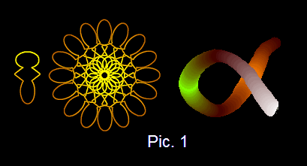
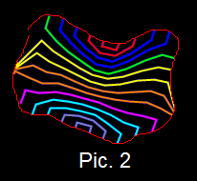
Images Generator as textures and images creator. In the program methods of creation of images that are based on use of multi-colour lines are used. A multi-colour line is the line, which is drawing not in one color but in the given sequence of colors. The program allows for each line point to specify color from the given sequence of colors. Color of adjacent line points can differ among themselves. For obtaining of a certain color sequence mathematical functions are used. The set of multi-colour lines is the vector image that may be saved in memory and may be used for creation of images. Creation of images is carried out by consecutive drawing of vector image at moving of the mouse or in points of a trajectory. In points of a trajectory the sizes and angles of turn of vector image can be changed.
Also for creation of images lines of variable width are used. Lines of variable width are lines, width of which changes according to the chosen mathematical law. The line can be simultaneously multi-colour line and a line of variable width (pic.1).
One of methods of creation of images is based on use for image area fill of lines of a complex configuration. The novel mathematical algorithm is applied for obtaining of such lines. Fill of the selected image area is carried out by consecutive drawing of lines. For drawing of every line all descriptions and coordinates of image area border points are used. This provides uniformity of placement of fill lines in selected area (pic.2). For each fill line color from specifying color sequence and a level of a transparency can be given. In the program some laws of change of a level of a transparency for a sequence of lines are built - in. It provides interesting graphic effects.

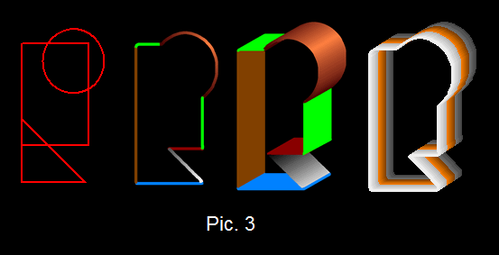
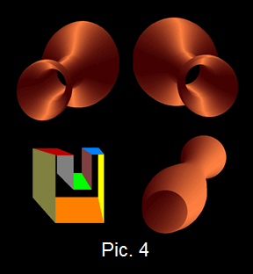
Images Generator as 3D images creator. In this program original methods of creation of 3D images are used. Two from these methods are based on use of the obtained by the user and saved in memory vector image together with trajectories. In points of a trajectory sizes and angles of turn of vector image may be changed according to the given functional dependences. In the first of two methods the set of multi-color lines is used as the vector image. The volumetric effect is provided by the specifying of the certain color sequence that is used in vector image. In the second of two methods set of one-color lines is used as the vector image. The volumetric effect is provided by specifying of the certain color sequence, which corresponds to points of trajectory. Drawing of vector image is carried out in corresponded color (pic.3, pic.4)
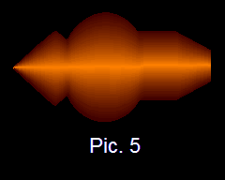
One more way of creation of 3D images is based on use for fill of the selected image area lines, which configuration is determined by the shape of border of Selection. The selected area is painted over by drawing of lines that are uniform located with high density. For each of line color from specified color sequence is used. It provides a number of graphic effects, including volumetric effect (pic5). Color of a line is specified with the help of the color panel of program dialog window. The color panel allows using a number of functions for specifying the length of a color sequence and order of colors in it.

Images Generator as collages creator. The program has many tools that are intended to select a part of the image. The selected part can be saved in memory and can be displaced by the mouse to required position. Thus the collage is created.
Selection tools share on 2 groups. The first group works by drawing lines with the mouse help to indicate the selection. The second group makes a selection by based upon the colors in the image. Segmentation methods by based upon the image colors are cited in [1-4]. The second group consists of two tools. The first tool allows to select image area consisting of points, color of which belongs to the given range. The second tool allows to select image area from background. Color of points of background border belongs to the given range.
Each tool has some modes that are distinguished among themselves by the used measure of closeness between points depending on their color. For definition of closeness of colors next measures are used:
- belonging of any component of RGB color model or their any combination to the given range.
- belonging of any component of HSL color model or their any combination to the given range.
- belonging of sum components of RGB color model to the given range.

Images Generator as photo transformer.
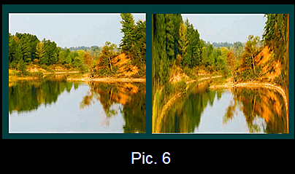
In the Images Generator the novel method of transformation of raster images is used. This method allows to obtain high-quality realistic images on the basis of the initial image. Type of transformation is determined by obtained by the user directional curve and by choosing one of modes of transformation. Modes of transformation are divided on two parts. One part of modes provides compression of the image in a vertical and horizontal direction or to the center of the image. Other part of modes provides enlargement of the image in a vertical and horizontal direction or from the center of the image. Directional curve may be obtained by using Selection tools and built-in shapes and mathematical curves.
One of the important areas of raster transformation method use is processing of photos (pic.6).

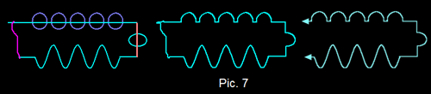
Images Generator as the program for technical designing. This program has a plenty of the built - in shapes as a rhombus or parallelogram and mathematical curves such as a sinusoid or a parabola. Program allows to obtain in tabular representation unlimited amount of the shapes and curves of a complex configuration by a combination of the built - in shapes, mathematical curves, splines and the hand drawn lines. For this purpose with the help of program tools and the built - in elements the figure of the required shape is drawn. To this figure the tool, providing selection of a part of the raster image with use of its color properties, is applied. The border of obtained selection determines a required curve. This curve is closed line. For obtaining open-ended line the part of the closed line is used. Such method is characterized by simplicity and efficiency (pic.7).
Curves of a complex configuration are used as the vector image for creation of volumetric models. They allow to select image area to fill and outline it or to apply for it graphic filters and converters. Curves of a complex configuration are used as directional line of curved text.
Images Generator can be used as schematic drawing program. All that are necessary for this is table of symbols. You choose a symbol and then place it in the schematic by dragging the mouse. Then use the pen or line tool to make connections.
The program allows to draw complex function diagrams, to design shades at any angle and to draw tables with any amount of columns and raws.

Combining of properties of various to destination programs in one program allows using Images Generator for the various purposes in a wide range of applications. Images Generator can be used as the program for creation of identikits, the program for choosing of hairstyles and clothes and the program for creation of portraits. The program can be used in the textile and paper industry.
The Images Generator can find wide application in a science and engineering. For example, with the help of the program you can to obtain the mathematical description of the received by scanning of processes curve or to construct the diagram of complex function.
The program can be studied for short time. Novice users and children can use program.

Resources

Graphic editor Images Generator site: http://www.imagesgenerator.com
Download Images Generator: http://www.imagesgenerator.com/ImagesGeneratorSetup.exe
Pad file: http://www.imagesgenerator.com/pad_file.xml

References
- Adobe systems incorp. 2002. Adobe Photoshop User Guide.
- Martin D., Fowlkes C., Tal D., Malik J. A Database of Human Segmented Natural Images and its Application to Evaluating Segmentation Algorithms and Measuring Ecological Statistics. Proceedings of 8th International Conference on Computer Vision. 2001. 2. N. 1. P. 416-423.
- Eilbert C. G. J., and McEachron, D., “The variation in user drawn outlines on digital images: Effects on quantitative autoradiography”. Compur. Med. Imag. Graphics, vol. 14, no. 5, pp. 331–339, 1990.
- Y. Boykov and M. P. Jolly. Interactive graph cuts for optimal boundary and region segmentation of objects in N-D imges. In ICCV, volume 1, pages 105–112, July 2001.

Figure captions.

Pic. 1. Using of multi-color lines and lines of lines of variable width.

Pic. 2. Fill of selected image area using lines of complex configuration.

Pic. 3. 3D image creation using vector images and trajectory.

Pic. 4. Change of sizes of vector image in trajectory points for 3D image creation.

Pic. 5. 3D image creation by drawing of sequence of lines. Color of lines changes in exponential dependence.

Pic. 6. Example of using raster transformation method.

Pic. 7. Obtaining of open-ended line of complex configuration.

Abstract

In graphic editor Images Generator novel methods of creation of 2D and 3D images are used. Program has many built-in shapes and let you to obtain unlimited amount of custom shapes. Two types of the tool Brush are used. There are Vector brush and Raster brush. In Vector brush vector image and in Raster brush raster image are used as brush tip. As Vector brush tip set of multi-color lines may be used. For creation of 3D images Vector brush is used together with trajectories.
In the Images Generator the novel method of transformation of raster images is used. Type of transformation is determined by obtained by the user directional curve and by choosing mode of transformation.

Author biography.
Scientist, and programmer with 30 years of experience in software and hardware systems design and development. Employers have included scientific organizations of the former Soviet Union. The founder and the head of software firm Panasoft. Led teams in development of patentable innovations in diverse areas, including image processing, PCB and IC CAD, automated systems of control and tests of electronic digital devices. The author about 40 scientific works and inventions.

Resource Box

Sergey Panasyuk is team leader in development of innovations in image processing and CAD. He is author and main developer of program Images Generator. Visit http://www.imagesgenerator.com for more cutting edge tips and techniques for creation and editing images.

Keywords.

Graphic tools, shapes, multi-color lines, creation of images, 3D graphic, volumetric images, Vector brush, Raster brush, graphic editors, portrait maker, photo transformation

